**Choice set construction and value**

*Adam Morris*

*Second year project*

**Introduction**

Humans are bombarded with immensely complicated decisions. Imagine a psychology student – Sally – deciding where to eat lunch. Sally has certain preferences (e.g. she likes Mexican food, dislikes walking long distances) and constraints (e.g. she’s deathly allergic to walnuts) that she should factor into their decision. Ideally, she would carefully evaluate all her options, and choose the one with maximal positive outcomes. For example, she might score each option based on how close it is to William James Hall, how Mexican its cuisine is, the likelihood that it uses walnuts, etc., and then choose the option with the highest score. This kind of forward planning has been intensively studied, and we have some understanding of how it could be accomplished (Dolan & Dayan, 2013; Doll, Simon, & Daw, 2012).

But in any real-world decision, there are an overwhelming number of potential options. There are hundreds of restaurants in Harvard Square, and thousands in the greater Boston area. And the problem is even worse than this, because Sally has more options than just restaurants: She could also grow the crops herself, or catch a wild animal to eat, or steal food from the communal refrigerator, etc. She couldn’t possibly evaluate all her options – she would die of starvation before she finished.

Yet people like Sally are able to make these decisions with speed and ease. How? Intuitively, people don’t consider all possible options – they construct a small set of options to evaluate, and ignore all the rest. For instance, Sally might only consider Darwin’s and Felipe’s, and choose one of those. The process by which people narrow down the enormous set of potential options to a small set of relevant choices is known as *choice set construction*.

The aim of this project is to characterize how choice sets are constructed. Not all options are equally likely to make it into someone’s choice set; people clearly favor some options (e.g. Darwin’s) over others (e.g. catching a wild animal). What determines which options make the cut? One potentially important factor is how good an option has been in the past (i.e. the option’s past value). Options that have been good in the past tend to be good in the future. Thus, the mechanism that constructs choice sets might be designed to propose options with high past values.

I explore this idea in two ways. First, I construct a computational model of value-guided choice set construction, and simulate its performance (and the performance of two alternative models) in various environments. When options that have been good in the past tend to be good in the future, the choice set model achieves good accuracy at low computational cost.

Second, in a behavioral experiment, I show that certain human decision patterns are uniquely consistent with the choice set model. I fit the model to people’s choices in the experiment, and find that about half of subjects use the prior value of options to guide their choice set construction. These results suggest that people spontaneously construct choice sets when faced with difficult decisions, and are often more likely to include options with high prior values in those choice sets.

**Computational model**

A schematic of the choice set model is depicted in Figure 1. There is a large pool of *N* potential options, each marked with a pre-computed past value. I assume that agents have learned these values from past experience, and do not explicitly model the learning process. The agent samples a small number of *K* options, without replacement, from this pool.

The sampling process is non-uniform, and is more likely to sample options with high past values. Let $Q_{i}$ be the stored past value of option *i*. Thenthe probability of sampling an option *i* is:

$$Prob\left(sampling option i\right)=p_{i}=\frac{e^{βQ_{i}}}{\sum_{j=1:N}{e^{βQ_{j}}}}$$

where $β$ is an inverse temperature parameter controlling the degree to which sampling is biased towards high-value options.

Non-uniform sampling without replacement is tricky, because maintaining stable sampling probabilities as the pool shrinks seems to require a costly renormalization after every sample. Fortunately, there is a simple, highly parallelizable algorithm that can sample without replacement in one pass over the options, without having to constantly renormalize. The agent simulates an exponentially distributed random number (with rate parameter 1) for each option, divides it by the option’s probability $p_{i}$, and chooses the *K* options with the lowest resulting numbers. This algorithm achieves the desired weighted sample. (See Efraimidis & Spirakis, 2006 and Müller, 2016 for proof and elaboration.)

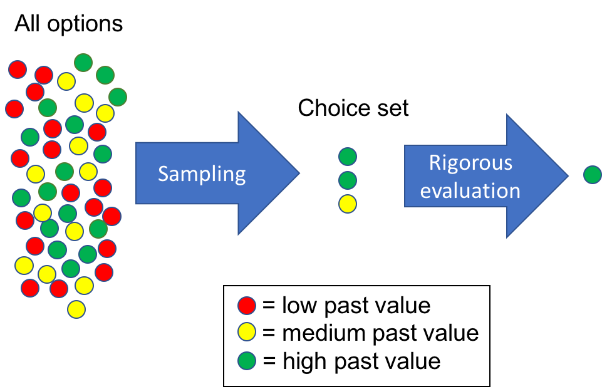

Figure 1: A schematic depiction of the choice set construction model.

Once the choice set is sampled, the agent chooses the option in the choice set with the highest value for the current decision. We assume that this happens via a laborious evaluation process (i.e. forward planning), and do not model it explicitly.

*Alternative models*

We compare the choice set model to two alternatives, which anchor the two ends of a spectrum of computational complexity (Figure 2). The “no planning” model does not perform any forward planning or evaluation of options in the current context, and simply samples an option with probability proportional to its past value. This process is extremely computationally cheap, but can be highly inaccurate if circumstances change.

In contrast, the “optimal planning” model rigorously evaluates all options in the current context, and chooses the best. This model achieves high accuracy, but with a large option set is intractable. The choice set model falls somewhere between these two extremes; it evaluates some options and thus engages in some forward planning, but much less than the optimal planning model. I show that, for a plausible range of environments, the choice set model provides major gains in accuracy over the no planning model, at a fraction of the cost of optimal planning.

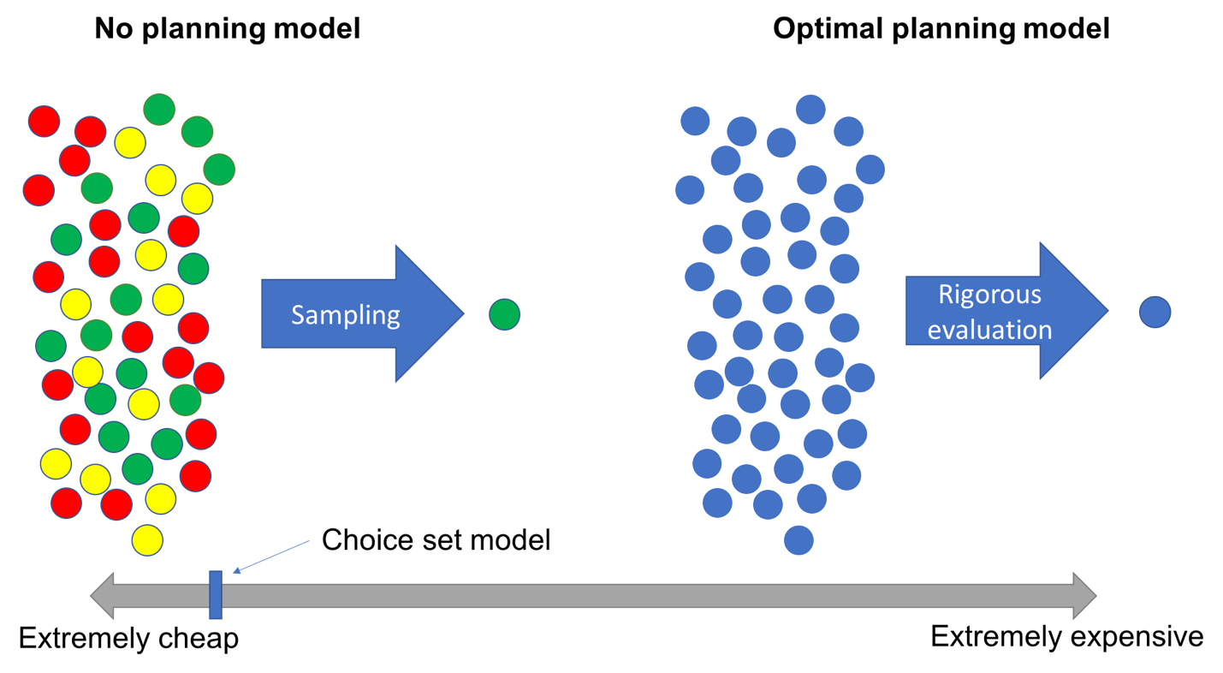

Figure 2: A schematic depiction of two alternative models. The no planning model is extremely computationally cheap; the optimal planning model is extremely expensive; and our choice set model falls somewhere in between.

*Simulation setup*

To show this, for each of the three models, I simulated 10,000 agents using that model to make decisions in five different environments. Each agent made a single decision in each environment, which consisted of choosing between *N =* 1000 options based on their past and/or present value. The past and current value of each option were simulated anew for each agent-environment pair. The no planning model sampled according to the options’ past values; the optimal planning model deterministically chose the option with the highest current value; and the choice set model used the past values to construct a choice set of size *K =* 10, from which it chose the option with the highest current value. Again, we assumed that agents learned these values through learning or planning, but we did not explicitly model the learning/planning processes.

The five environments differed solely in the simulated correlation between past and current values. The values were drawn from lognormal distributions with correlation either 0, .25, .5, .75, or 1. (The lognormal distribution embodied the assumption that most of the options available to us are bad, while only a few are good.)

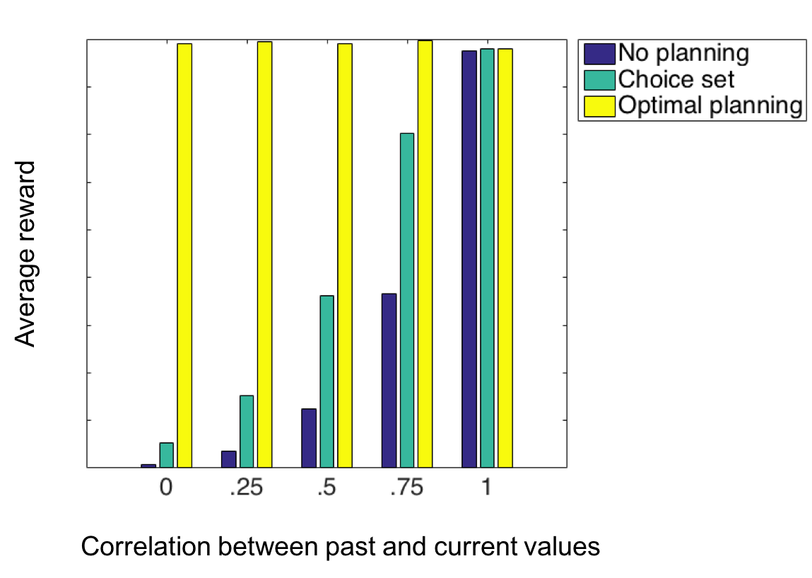

Figure 3: Simulated earnings of the three models across five environments.

*Simulation results*

The simulation results are shown in Figure 3. As expected, the optimal planning model achieves the highest accuracy across all environments (but at an extreme computational cost). Moreover, when the correlation between past and current values is low – i.e. when the past value of options is not indicative of their current value – then both the no planning and choice set models perform poorly.

Crucially, however, there is a sweet spot where choice set models are adaptive. When past values are highly but not perfectly predictive (e.g. *r* = .75), the choice set model performs almost twice as well as the no planning model, with accuracy approaching the optimal planning model, at a low computational cost.

**Behavioral experiment**

Next, I tested whether people construct value-guided choice sets when faced with difficult decisions. To test this, I employed an experiment with two stages. The idea was to expose people to a large set of different-value options in Stage 1, and then ask them to make decisions using those options in Stage 2. The resulting decision patterns could be tested for signatures of value-based choice set construction.

*Design*

In Stage 1 of the experiment, participants were exposed to a set of fourteen common English nouns (e.g. “basket”, “community”, “machine”). Each word was associated with some amount of bonus points. For instance, “basket” might have been worth 10 points, and “community” might have been worth 0. Half of the words were randomly chosen to have a low point value (either 0, 1, or 2 points), and half to have a high point value (either 8, 9, or 10 points). (Points were translated into bonus money at the end of the experiment.)

In order to learn these word-value associations, in Stage 1 participants played a game where they repeatedly chose between a word and a fixed number of points (Fig. 4). For instance, on one trial, a person might have had to choose between “basket” and 5 points. If they chose the word, they earned however many points it’s worth. If they chose the fixed number of points, they received that many points. Thus, participants were incentivized to learn the word-value associations and use that knowledge to win more bonus points throughout the game.

Participants completed 8 trials per word, for a total of 112 trials. Importantly, no matter what they chose, we showed the word’s point value on each trial. This procedure guaranteed that people were exposed to each word an identical number of times. To further ensure that people learned the word-value associations, we asked participants to retype the word and its value after each trial.

Then, in Stage 2, participants faced a series of decisions like: “Give us a word from Stage 1 with the most number of vertical lines in its letters. You’ll win 10 points for each vertical line in the letter of your word.” In these questions, the potential options were the words from Stage 1, and each option was difficult to evaluate. There were 8 decisions in total. For each decision, participants were given an example and a comprehension check. All decisions had a time limit, which was calibrated *a priori* to the difficulty of each decision (e.g. the vertical lines decision had a time limit of thirty seconds.)

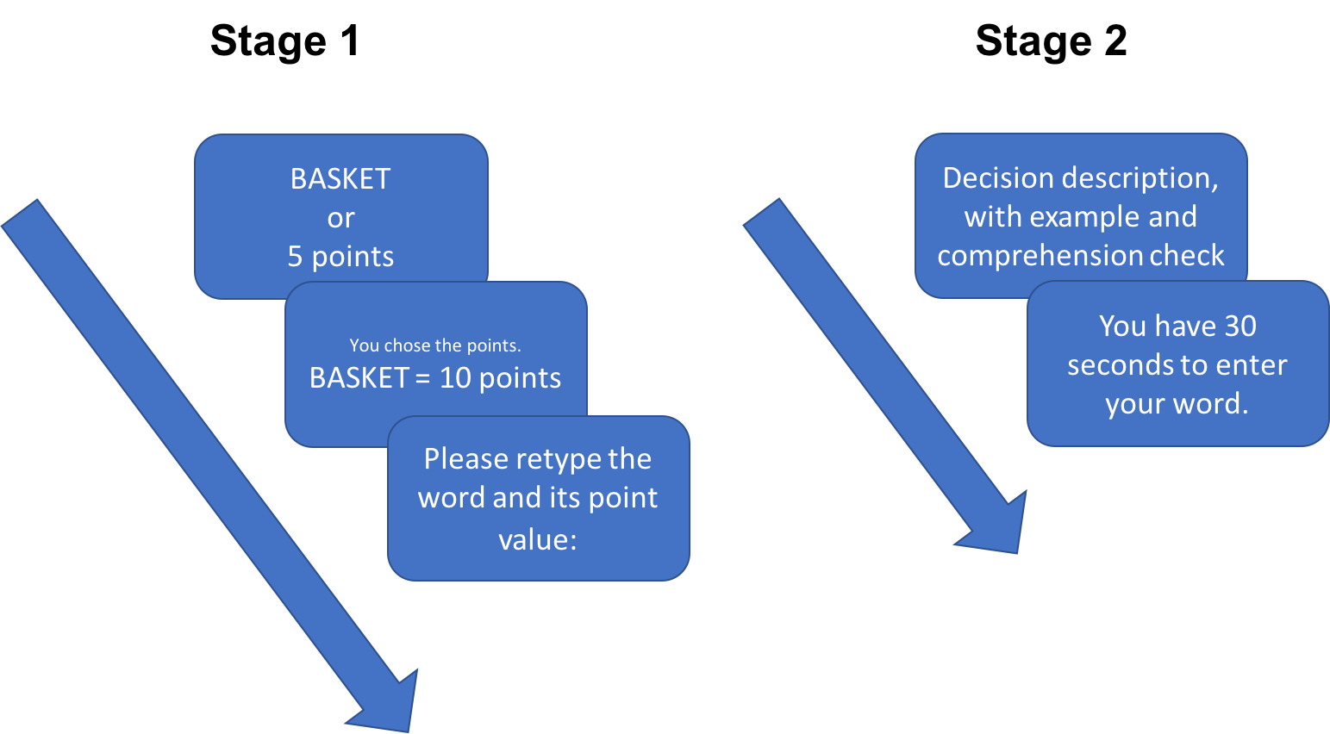

Figure 4: Design of the two-stage experiment.

I hypothesized that, to make these decisions, people would construct a small set of words to evaluate, and that words with high Stage 1 point values would be more likely to enter this choice set. This choice mechanism leaves a particular fingerprint. If people are employing my choice set model, then the Stage 1 value (e.g. “basket” = 10 points) and Stage 2 value (e.g. number of vertical lines in “basket”) of a word will interact to influence choices in Stage 2. Intuitively, this interaction arises because, if people are constructing a set of choices that have high Stage 1 value and choosing among them based on their Stage 2 value, then an increase in Stage 2 value (which makes an option more likely to be chosen if it’s in the choice set) will have a larger effect on choice when the Stage 1 value is high (because the option will have a greater chance of making it into the choice set).

In contrast, the two other models only predict main effects: The no planning model predicts a main effect of Stage 1 value on choice, and the optimal planning model a main effect of Stage 2 value on choice. Thus, an interaction is uniquely predicted by the choice set model. By simulating my computational model on a simplified version of the task, I confirmed this intuition: The interaction appears if and only if simulated agents are constructing choice sets based on Stage 1 value.

*Results*

The results are shown in Figure 5. Graphically, the interaction pattern is visible: people were more likely to choose words with high Stage 1 values, selectively for words with the highest Stage 2 values. We analyzed these data with a multinomial logit model, regressing Stage 2 choice on Stage 1 value, Stage 2 value, and their interaction. The interaction was marginally significant (coefficient = .045, *t* = 1.87, *p* = .06). This result suggests, but does not conclusively demonstrate, that people are using Stage 1 value to construct choice sets. We are planning a pre-registered replication to confirm the finding.

As an additional analysis, I fit our computational model and various alternatives to participant choices. For each type of model (choice set, no choice set), I fit several variants, shown in Table 1. I computed the maximum *a posteriori* estimates for all parameters, using a Gamma prior for the inverse temperatures and a uniform prior for the mixture weights and choice set size. The possible choice set sizes were restricted to {2, 3, 4}. I then performed Bayesian model selection by entering the model evidences (computed with the Laplace approximation) into the spm_BMS routine in SPM8. The overwhelmingly preferred model, with an exceedance probability of 1, was the choice set model which used both Stage 1 and Stage 2 value to construct choice sets was overwhelmingly preferred. This result likely indicates that, before computing Stage 2 value, people had access to some rough pre-computed estimate of the Stage 2 values, which they could use to influence choice set construction. (Note that this does not remove the need to evaluate the options further; the pre-computed estimate could be very rough, and further evaluation of the options in the choice set would likely still be beneficial.)

The best-fit weights for the influence of Stage 1 value on that process are shown in Figure 6, for each subject. Importantly, in about half of subjects, words with high Stage 1 values were more likely to make it into their choice sets.

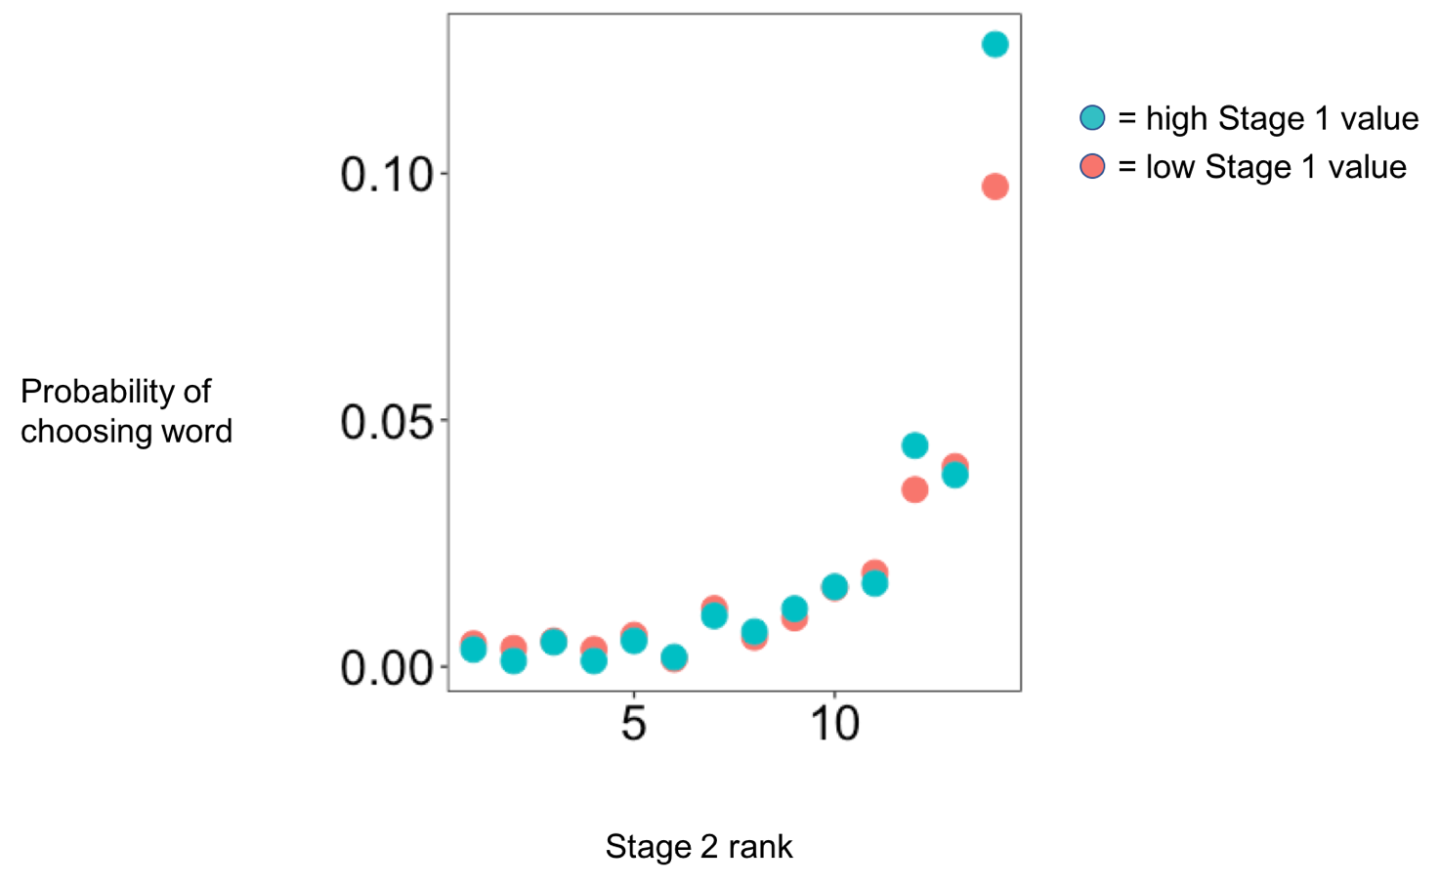

Fig. 5: The probability that people chose words with different Stage 1 and Stage 2 values. The x-axis is the Stage 2 rank of the word (1 is the lowest-value word for that question, 14 the highest), and the color indicates whether the word had a high or low Stage 1 value.

|  |  |  |  |
| --- | --- | --- | --- |
| **Family** | **Model** | **Description** | **Parameters** |
| Choice set | Stage 1 value | Used Stage 1 value to sample a choice set. Chose among the options in choice set in proportion to their Stage 2 value. | $β_{1}:$ inverse temperature for choice set softmax $β_{2}:$ inverse temperature for choice softmax $K:$ choice set size |
| Choice set | Stage 2 value | Same as above, but used Stage 2 value to construct choice set. | Same as above |
| **Choice set** | **Both** | **Same as above, but used a mixture of Stage 1 and Stage 2 value to construct choice set.** | **Same as above, with: $w_{S1},w_{S2}:$**  **mixture weights for choice set softmax** |
| Choice set | Random | Same as above, but sampled choice set uniformly. | $β_{2}:$ inverse temperature for choice softmax |
| Non-choice-set | Stage 1 value | Chose among options in proportion to their Stage 1 value (i.e. no planning model). | Same as above |
| Non-choice-set | Stage 2 value | Chose among options in proportion to their Stage 2 value (i.e. optimal planning model). | Same as above |
| Non-choice-set | Both | Chose among options in proportion to a mixture of Stage 1and Stage 2 value. | Same as above, with: $w_{S1},w_{S2}:$ mixture weights for choice softmax |
| Non-choice-set | Random | Chose among options uniformly at random. | None |

Table 1: Models fit to participant choices. The bolded model was preferred.

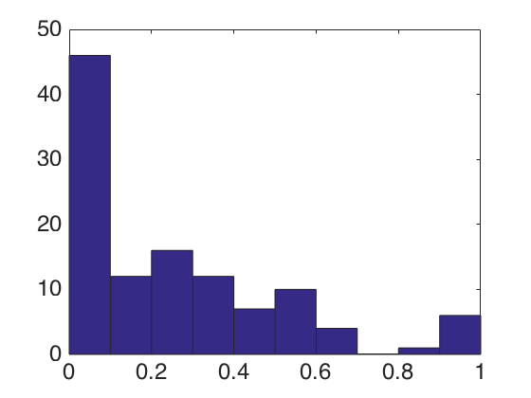

Weight on Stage 1 value

Frequency

Fig. 6: Distribution of weights of the influence of Stage 1 value on choice set sampling, across subjects.

**Conclusion**

In sum, decisions with large option sets can be tackled by constructing choice sets, and using the prior value of options to bias the choice set sampling procedure. I showed that, under certain environmental conditions, this model can achieve major accuracy gains at low computational cost. Moreover, in a novel behavioral experiment, I showed that a large percentage of people appear to spontaneously employ this decision strategy. This finding is a step towards understanding how people make quick, effective decisions in environments of real-world complexity.

**References**

Dolan, R. J., & Dayan, P. (2013). Goals and Habits in the Brain. *Neuron*, *80*(2), 312–325. https://doi.org/10.1016/j.neuron.2013.09.007

Doll, B. B., Simon, D. A., & Daw, N. D. (2012). The ubiquity of model-based reinforcement learning. *Current Opinion in Neurobiology*, *22*(6), 1075–1081. https://doi.org/10.1016/j.conb.2012.08.003

Efraimidis, P. S., & Spirakis, P. G. (2006). Weighted random sampling with a reservoir. *Information Processing Letters*, *97*(5), 181–185. https://doi.org/10.1016/j.ipl.2005.11.003

Müller, K. (2016). Accelerating weighted random sampling without replacement. *Arbeitsberichte Verkehrs- Und Raumplanung*, *1141*. Retrieved from http://e-citations.ethbib.ethz.ch/view/pub:176429